**9.1 Anatomy of the Digestive System**

* Intracellular digestion
  + Involves the oxidation of glucose and fatty acids to make energy
* Extracellular digestion
  + Occurs in the lumen of the alimentary canal (from mouth to anus)
  + “Outside” the body = outside the cell borders
* Mechanical digestion
  + Physical breakdown of large food particles into smaller food particles
* Chemical digestion
  + Enzymatic cleavage of chemical bonds e.g. the peptides of proteins, the glycosidic bond of starches
* Pathway
  + Oral cavity → pharynx → esophagus → stomach → small intestine → large intestine → rectum
* Accessory organs of digestion
  + Salivary glands, pancreas, liver, gallbladder
* Enteric nervous system
  + A collection of hundred million neurons (found in the walls of the digestive tract) that govern the function of the gastrointestinal system → trigger **peristalsis**
    - Upregulated by PNS (rest-and-digest)
    - Downregulated by SNS (fight-or-flight)

**9.2 Ingestion and Digestion\***

* Multiple hormones regulate feeding behaviour
  + ADH (or vasopressin) and aldosterone → promote thirst
  + Glucagon and ghrelin → promote hunger
  + Leptin and cholecystokinin → promote satiety

Oral Cavity

* Mechanical digestion (mastication = chewing)
  + Increases SA-to-vol ratio of the food → more SA for chemical digestion
  + Moderate the size of the food particles entering the lumen of the canal → bolus
* Chemical digestion (enzymes from saliva produced by 3 pairs of salivary glands)
  + Moisten and lubricate food → aids mechanical digestion
  + Contains salivary amylase (aka ptyalin) → hydrolyze starch into smaller sugars (maltose and dextrins)
  + Contains lipase → catalyze the hydrolysis of lipids

Pharynx

* Connects the mouth and posterior nasal cavity to the esophagus
* Divided into three parts
  + Nasopharynx (behind the nasal cavity)
  + Oropharynx (at the back of the mouth)
  + Laryngopharynx (above the vocal cords)
* Food is prevented from entering the larynx during swallowing by the **epiglottis** → failure can lead to aspiration of food and choking

Esophagus

* Muscular tube that connects the pharynx to the stomach
* No mechanical or chemical digestion takes place here, except for the continued enzymatic activity initiated in the mouth by salivary enzymes
* Three parts
  + Top ⅓ composed of skeletal muscles → somatic (voluntary) motor control
  + Bottom ⅓ composed of smooth muscle → autonomic (involuntary) nervous control
  + Middle ⅓ is mixed of skeletal muscles and smooth muscle

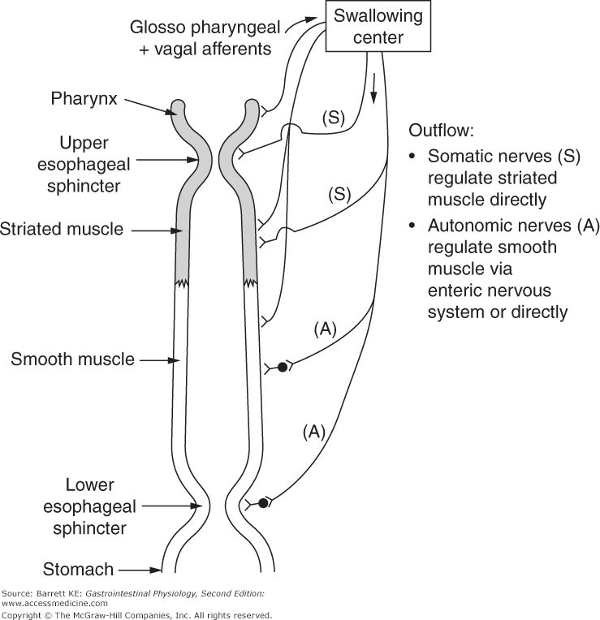

Stomach

* Highly muscular and distensible organ
* Four main anatomical divisions
  + Fundus and body: contain mostly **gastric glands**
    - Respond to vagus nerve of the PNS, which is activated by the brain in response to sight, taste, and smell of food
    - Three types of cell
      * Mucous cells → **produce bicarbonate mucus** to protect the stomach
      * Chief cells → **secrete pepsinogen**, a protease activated by the acidic environment of the stomach → becomes pepsin (aids in protein digestion)
      * Parietal cells → **secrete HCl** (to cleave pepsinogen to pepsin + kill microbes + denature proteins) and intrinsic factor (glycoprotein needed for vitamin B12 absorption)
  + Antrum and pylorus: contain mostly **pyloric glands**
    - Contain G cells that secrete **gastrin**, a peptide hormone
      * Induces parietal cells in the stomach to secrete more HCl
      * Signals the stomach to contract → increases gastric motility → makes chyme → increases SA for absorption in the small intestine

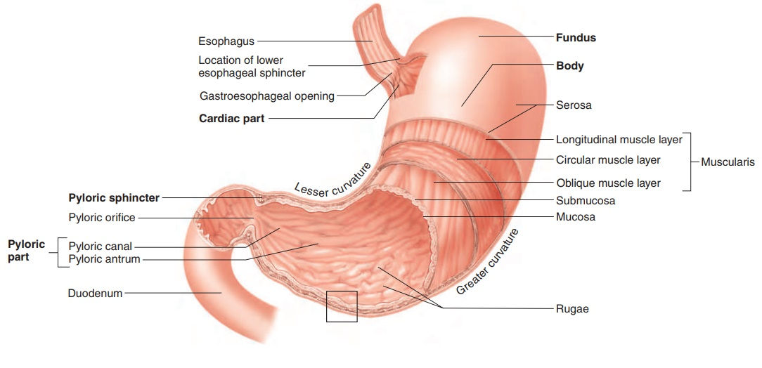

Duodenum

* The first part of the small intestine, and is primarily involved in chemical digestion
  + **Brush border enzymes** (disaccharidases e.g. maltase, lactase, sucrase + peptidases e.g. aminopeptidase, dipeptidase)
    - Release is caused by the presence of chyme
    - Break down bio-molecules into absorbable monomers
  + Enteropeptidase (formerly called enterokinase)
    - Activates trypsinogen (pancreatic protease) to trypsin → activation cascade
    - Activates procarboxypeptidase
  + Secretin (pancreatic hormone)
    - Reduces HCl secretion from parietal cells → regulates the pH of the digestive tract
    - Causes pancreatic enzymes to be released into duodenum + increases bicarbonate secretion from the pancreas
    - Enterogastrone → slows motility through the digestive tract → increases time for digestive enzymes to act on chyme, esp fats
  + Cholecystokinin (CCK)
    - Promotes satiety in the brain
    - Stimulates the release of bile into the duodenum
      * Bile = complex fluid composed of bile salts (derived from cholesterol), pigments and cholesterol
      * Not enzymes → do not perform chemical digestion
      * Bile salts emulsify fats and cholesterol into micelles (mechanical digestion) → increase their solubility and SA for **water-soluble** pancreatic lipase to act on (chemical digestion)
    - Stimulates the release of pancreatic juices into the duodenum
      * Pancreatic juices = complex mixture of several enzymes in a bicarbonate-rich alkaline solution
        + Neutralize the acidic chyme
        + Provide an ideal working environment for each of the digestive enzymes (active pH ~ 8.5)
      * Contains enzymes that can digest all three types of nutrients: carbohydrates, proteins, and fats

**9.3 Accessory Organs of Digestion**

Pancreas

* Endocrine function
  + Release of insulin, glucagon, somatostatin → regulate blood sugar levels
* Exocrine function
  + Contain acinar cells that produce pancreatic juices that contain:
    - Bicarbonate
    - Pancreatic amylase
    - Pancreatic peptidase (trypsinogen, chymotrypsinogen, carboxypeptidases A and B)
    - Pancreatic lipase

Liver

* **Synthesizes bile**, which can be **stored in the gallbladder** or secreted into the duodenum directly
  + Bile emulsifies fats, making them soluble and increasing their surface area
  + The main components of bile are bile salts, pigments (esp **bilirubin** from the breakdown of hemoglobin), and cholesterol
    - Bilirubin travels to the liver, where it is conjugated (attached to a protein) and secreted into the bile for excretion
    - Liver damage, excessive RBC destruction, blockage of bile ducts → unable to process or excrete bilirubin → jaundice (yellowing of the skin)
* Processes nutrients (through glycogenesis and glycogenolysis, storage and mobilization of fats, and gluconeogenesis)
* Modifies ammonia (a toxic waste product of amino acid metabolism) to urea, which can be excreted by the kidneys
* Detoxifies chemicals, activates or inactivates medications
* Synthesizes albumin
  + A protein that maintains plasma oncotic pressure
  + Serve as a carrier for many drugs and hormones
* Synthesizes clotting factors
  + Aid blood coagulation

Gallbladder

* Located just beneath the liver and both **stores and concentrates bile**
* Upon release of CCK, the gallbladder contracts → pushes bile out into the biliary tree
* Common site of cholesterol and bilirubin stone formation → inflammation of the gallbladder
  + Stones may travel into the bile ducts and get stuck in the biliary tree
  + Blockage of pancreatic duct → pancreatitis

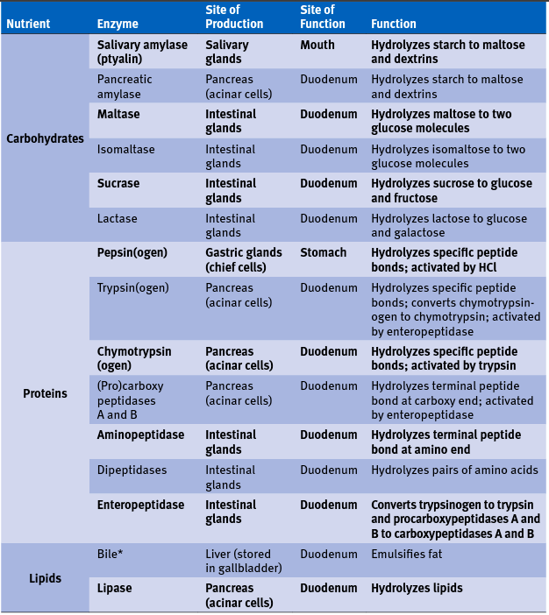

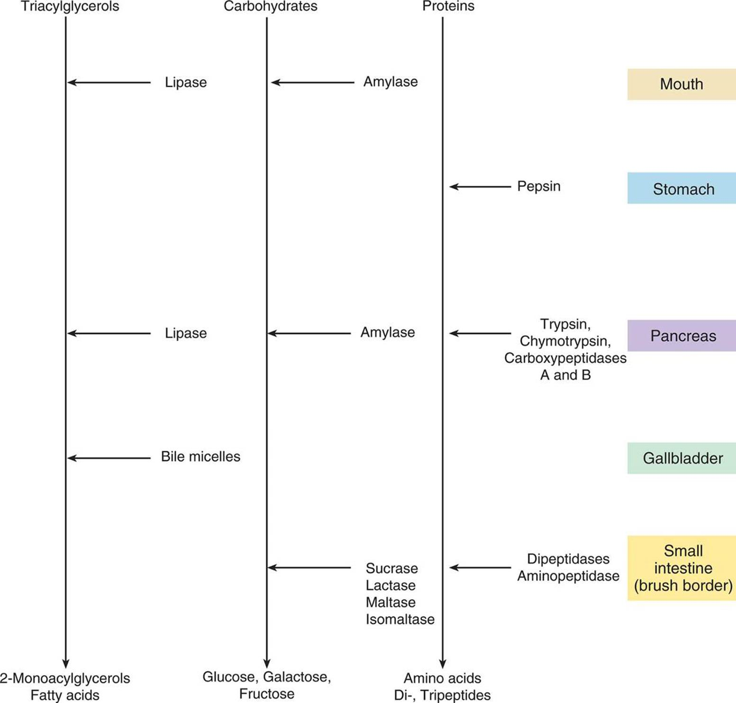

**9.4 Absorption and Defecation**

Jejunum and Ileum

* Primarily involved in absorption
* Lined with villi, which are covered by microvilli → **increase the SA available for absorption**
* Villi contain a capillary bed and a lacteal (a vessel for the lymphatic system)
  + Water-soluble compounds e.g. monosaccharides, amino acids, water-soluble vitamins, small fatty acids, and water enter the capillary bed
  + Fat-soluble compounds e.g. fats, cholesterol and fat-soluble vitamins, enter the lacteal

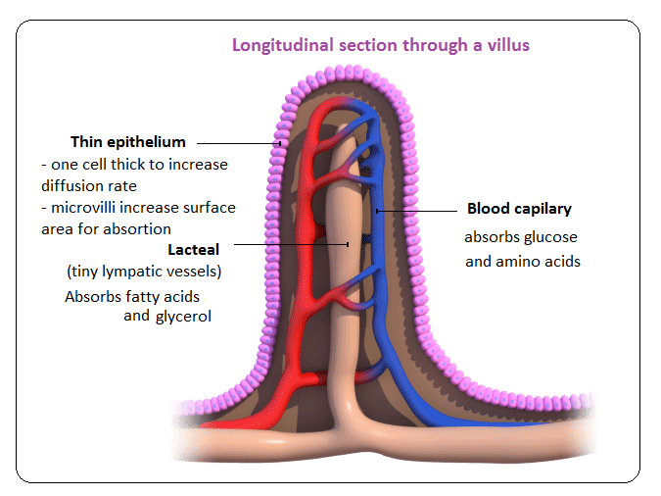

Large Intestine

* **Absorbs water and salts**, forming semi-solid feces
* Divided into three parts
  + Cecum
    - Outpocketing that accepts fluid from the small intestine through the ileocecal valve
    - Site of attachment of the appendix
  + Colon
    - Ascending, transverse, descending, and sigmoid portions
  + Rectum
    - Stores feces, which are then excreted through the anus
* Gut bacteria produce vitamin K and biotin (vitamin B7)